**Server Status Indicator**

**Purpose**

This project is developed to give users access to excessively used servers and its tasks.

**Project made of**

1. Web Application
2. Console Application
3. Web service
4. AES Encrypt Decrypt

**Requirements**

Windows 7 and above.

**Folder Structure of Project**

*- denotes mandatory files and folders which should be present in the project to successfully run the project.

Web Application

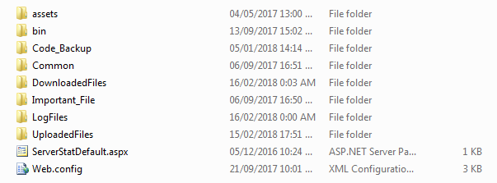

1. **assets** * **–** contains the project jquery files.
2. **bin** *– contains the project dlls.
3. **Code_Backup** - To keep backup of the previous setup when new changes are to be updated.
4. **Common** *– contains the project aspx pages.
5. **DownloadedFiles** – contains copy of files which are downloaded from the server.
6. **Important_File** *-contains this and this file.
7. **LogFiles** - contains log of the project whenever the project runs.
8. **UploadedFiles –** contains copy of files which are uploaded on the server.
9. **ServerStatDefault.aspx** * – The project default page.
10. **Web.config** * – The project configuration file.

Console Application

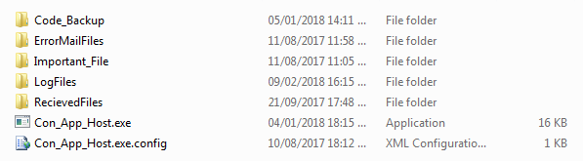

1. **Code_Backup** - To keep backup of the previous setup when new changes are to be updated.
2. **ErrorMailFiles** *– Contains “errorMail.txt” named text file having timestamp for sending Error Message in Error Log of Les Monitor. To avoid constant error sending the time is kept to send error after each 1 hour.
3. **Important_File** *-contains this file.
4. **LogFiles** - contains log of the project whenever the project runs.
5. **RecievedFiles** * **–** It is a combined data of these files for each server specified in this file.
6. **Con_App_Host.exe** * – The project default page.
7. **Con_App_Host.exe.config** * – The project configuration file.

Web service

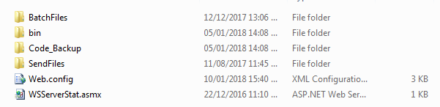

1. **BatchFiles** *– contains Batch files for running, enabling, disabling tasks.
2. **bin** *– contains the project dlls.
3. **Code_Backup** - To keep backup of the previous setup when new changes are to be updated.
4. **SendFiles** * - contains “XMLData.xml” and “XMLTaskData.xml” file.
5. **Web.config** * – The project configuration file.
6. **WSServerStat.asmx** * – The project asmx file.

**Deployment-**

The **Web Application** and the **console application** (put on scheduler to run daily for every 1 hour) should be installed on one particular computer (installed on 248 server) where all the server’s **web service**can be accessed. The Web service should be configured on all the servers.

**Process Diagram-**

Web Application

Console Application (runs on scheduler for every 1 hour)

For status of Servers and their scheduled tasks and the server time

For “Restart” virtual PC, Rerun, Enable, Disable Scheduled Tasks, Upload, Download, Delete and Archive Files, Refresh Folders.









Task Tracker Console put on scheduler

Web Service

**Configuration File**

Web Application

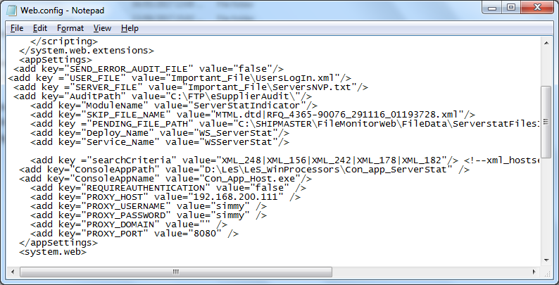

|  |  |
| --- | --- |
| **Key** | **Value** |
| SEND_ERROR_AUDIT_FILE | True for creating logs to be seen in “Les Monitor”. |
| USER_FILE | Path where this website users login file is kept like this. |
| SERVER_FILE | Path where the servers which all are to be accessed is kept as this. |
| AuditPath | Path where the audit log file will get created. |
| ModuleName | The name to be displayed as “Module” in the Audit log tab of “Les Monitor”. |
| SKIP_FILE_NAME | Names of the files to be skipped while accessing the server folder files by this and this way. |
| PENDING_FILE_PATH | Path where this folders are specified for each server. |
| Deploy_Name | IIS Deployed name of the web service. |
| Service_Name | Name of the service of the web service. |
| SearchCriteria | Criteria of the files to search on this path containing all server and VPCs status and its respective task status details. Separated by “|” , specify only the “MAIN” PCs File name. |
| ConsoleAppPath | Path where this console application is present. |
| ConsoleAppName | Name of the Console application. |
| REQUIREAUTHENTICATION | False if no authentication required to call web service. |
| PROXY_HOST | Proxy IP address to call web service. |
| PROXY_USERNAME | Proxy Username to call web service. |
| PROXY_PASSWORD | Proxy Password to call web service. |
| PROXY_DOMAIN | Proxy Domain to call web service. |
| PROXY_PORT | Proxy Port to call web service. |

Console Application

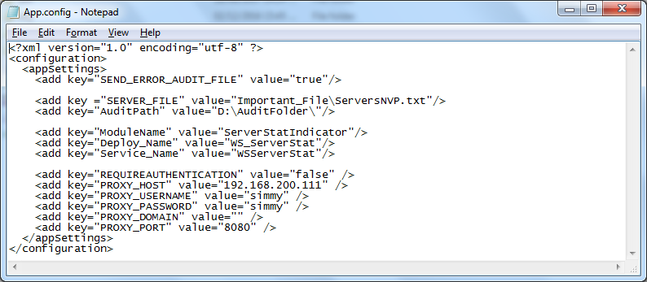

|  |  |
| --- | --- |
| **Key** | **Value** |
| SEND_ERROR_AUDIT_FILE | True for creating logs to be seen in “Les Monitor”. |
| SERVER_FILE | Path where the servers which all are to be accessed is kept like this. |
| AuditPath | Path where the audit log file will get created. |
| ModuleName | The name to be displayed as “Module” in the Audit log tab of “Les Monitor”. |
| Deploy_Name | IIS Deployed name of the web service. |
| Service_Name | Name of the service of the web service. |
| REQUIREAUTHENTICATION | False if no authentication required to call web service. |
| PROXY_HOST | Proxy IP address to call web service. |
| PROXY_USERNAME | Proxy Username to call web service. |
| PROXY_PASSWORD | Proxy Password to call web service. |
| PROXY_DOMAIN | Proxy Domain to call web service. |
| PROXY_PORT | Proxy Port to call web service. |

Web Service

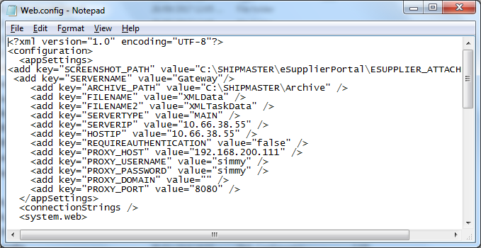

|  |  |
| --- | --- |
| **Key** | **Value** |
| SCREENSHOT_PATH | Path where screenshot takers screenshot image is created, used by **Screenshottaker** project (Les Attachments path). |
| SERVERNAME | Name of the server where this web service is running. |
| ARCHIVE_PATH | Path where the files will be archived. |
| FILENAME | Name of the file containing server details will be created in “Send Files” folder present on this web service exe path. |
| FILENAME2 | Name of the file containing scheduled task details which is created by **task status tracker project** which will be createdin “Send Files” folder present on this web service exe path. |
| SERVERTYPE | Should be “MAIN” for parent PC and “VIRTUAL” for Virtual PC. |
| SERVERIP | The accessible IP address of the server where this exe is deployed. |
| HOSTIP | The accessible IP address of the parent server on which this exe is deployed. If the server is “MAIN” server both the IP address will be same. If the server is “VIRTUAL” then IP address of its parent server is specified. |
| REQUIREAUTHENTICATION | False if no authentication required to call web service. |
| PROXY_HOST | Proxy IP address to call web service. |
| PROXY_USERNAME | Proxy Username to call web service. |
| PROXY_PASSWORD | Proxy Password to call web service. |
| PROXY_DOMAIN | Proxy Domain to call web service. |
| PROXY_PORT | Proxy Port to call web service. |

**Functionality**

Web Application

Works as a front end for accessing all the servers and its virtual PCs.

Files in the Folder name “Important _File” present in Web application project

1. ­­ServersNVP.txt

This file is the one which gives frontend view of all the servers in tiles. If one wants to remove the server as a tile then delete the line in this file for that particular server. If one wants to see the tile add the line in this file.

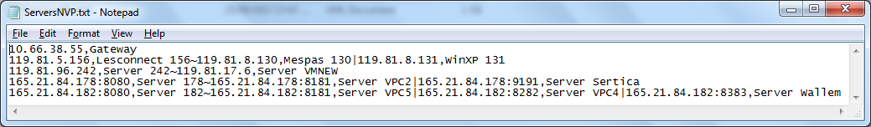

If Server does not have virtual PC then, specify IP address and Server name separated by comma as highlighted with “**Orange**” box in the above screenshot.

If Server does have one virtual PC then, specify IP address and Server name separated by “,” with “~” between the “MAIN” and the “VIRTUAL” server as shown highlighted with “**Brown**” box in the above screenshot.

If Server does have more than one virtual PCs then, specify IP address and Server name separated by “,” with “~” between the “MAIN” and the “VIRTUAL” and “|” between the first and second or second and third “VIRTUAL” PCs and so on as shown highlighted with “**Blue**” box in the above screenshot.

Note: - The IP addresses should be the one which are publicly accessible and have this webservice accessible by it.

1. UsersLogIn.xml

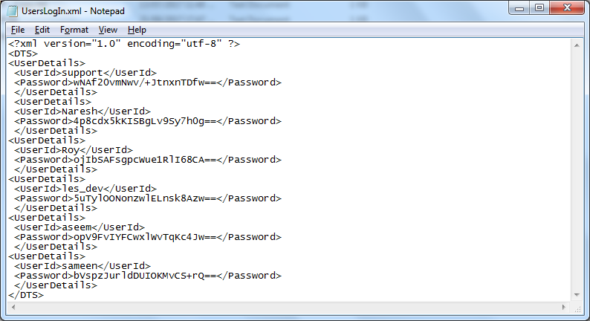

This file is the file containing UserId and Password for the users to log in to the server status indicator web site. If one wants to remove access to a user delete the “UserDetails” Parent node from this file and if one wants to add a new user access then add the “UserDetails” Parent node in this file. The “UserId” is the Username which is not case sensitive and the “Password” is AES encrypted which makes it case sensitive. To encrypt or decrypt a password use this utility.

Console Application

This console application finds these files and combines it in one file in this folder.

Files in the Folder name “Important _File” present in Console application project

1. ServersNVP.txt

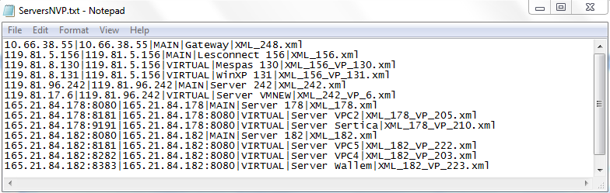

If “MAIN” Server then, specify accessible IP address, display IP address, ”MAIN” string, Server name, xml file name as “XML_”+any recognizable number of the server which is unique in this file, separated by “|”.

If “VIRTUAL” Server then, specify accessible IP address of the “VIRTUAL”, display IP address of the “MAIN” server where this “VIRTUAL” PC is present, ”VIRTUAL” string, Server name, xml file name as “MAIN” server xml file name succeeded by “_VP_”+any recognizable number of the server which is unique in this file, separated by “|”.

Web Service

This web service contains all the functions to be executed on the servers. It acts as a connector between client and server.

Files in the Folder name “­SendFiles” present in Console application project

1. XMLData.xml

Contains Server details of the server where this web service is present.

1. XMLTaskData.xml

Contains scheduled task details of the server where this web service is present.

AES Encrypt Decrypt

To encrypt and decrypt string using AES (Advanced Encryption Standard).

1) **Browsing URL**

portal.lighthouse-esolutions.com/les_serverstatus.

Usernames- support, naresh, roy, les_dev, aseem, sameen

Passwords (case sensitive should be small case)- support, naresh, roy1234, dev2016, asm123, sam1234

2) **Login**

Enter the username and password and then click on “Login” Button.  
 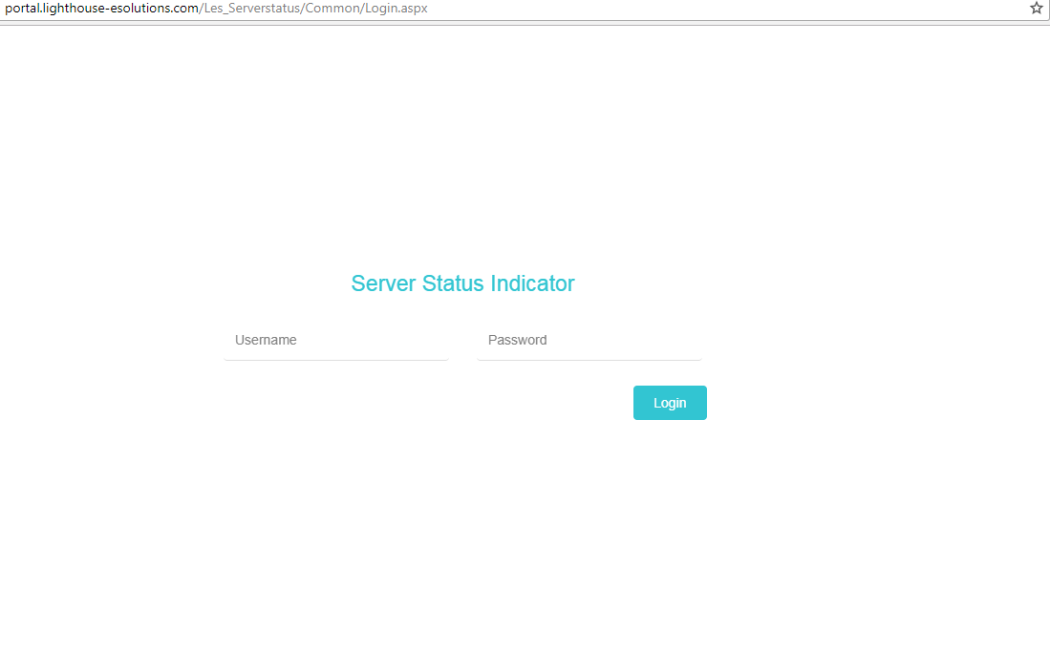  
  
3) After successful login, the user will be directed to below page.  
 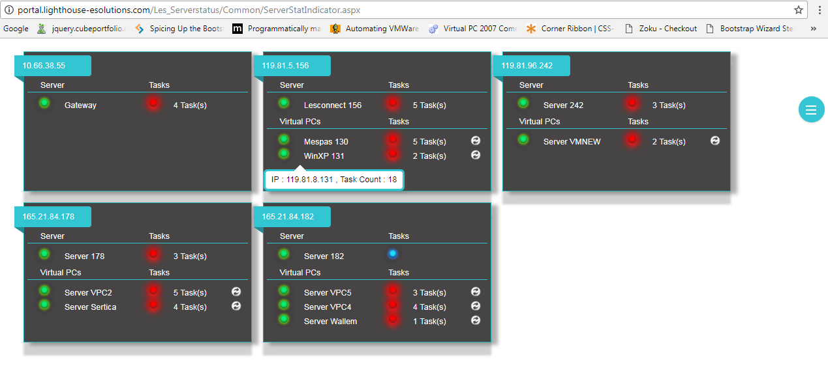

Each tile represents a server.

1

2

3

4

5

6

7

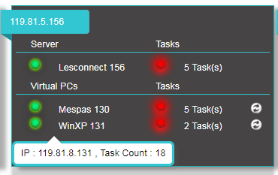

8

1. Specifies the **IP address** of the Server.
2. Specifies **the Host server name** and its **status**.
3. LED present near the server name or the Virtual PC’s server name shows the status of the server.
   1. LED Green-the server is running and is accessible.
   2. LED Red- the server is not accessible.
   3. LED Blue- there is no status found for the server if it is on/off or if accessible/ not accessible.
4. Specifies the Virtual PC’s present on the Host server, with its name and status. LED represents the status of the server. The description for LED is same as this.
5. Specifies the Tasks present on the Task scheduler of the server
6. LED present near the task or the Virtual PC’s task shows the status of the tasks (s).
   1. LED Green-all tasks (s) are enabled and running properly and are returning success code value.
   2. LED Red- the number of tasks (s) which are disabled or not running successfully or are returning error code values.
   3. LED Blue- there is no status found for the tasks (s) of the particular server or there are no tasks present.
7. It appears on hover of the Host server name and on the Virtual server names. It specifies the IP address of the server with total number of tasks present on the task scheduler of the respective server.
8. Opens Modal popup to **restart** the particular virtual server wherein a **scheduled task** named “**RestartPC**” will run a batch file containing “restart” command.

4) **Quick Navigation Button**

The highlighted control in red in below image is the quick navigation button.



On clicking, it will expand as shown in the image below. 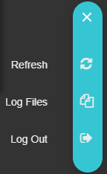

**Refresh**- On click of this option will execute the console application which gets all the servers information. After clicking on this and wait for some time and refresh the page will give you updated status of the servers.

**Log Files**- On click of this option will display a popup modal dialog as shown in the below image.

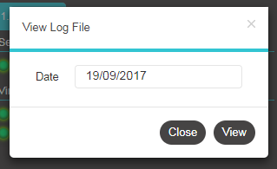

The user will first select the date of the log file to be seen and then click on “View”. A new window will open with the content of the log file of the selected date.

Button “Close” will close the popup modal dialog.

**Log Out**- On click of this option the user will be logged out.

5) On click of the server LED or its name, the page shown in the below image will be displayed only if the LED is Green in color.

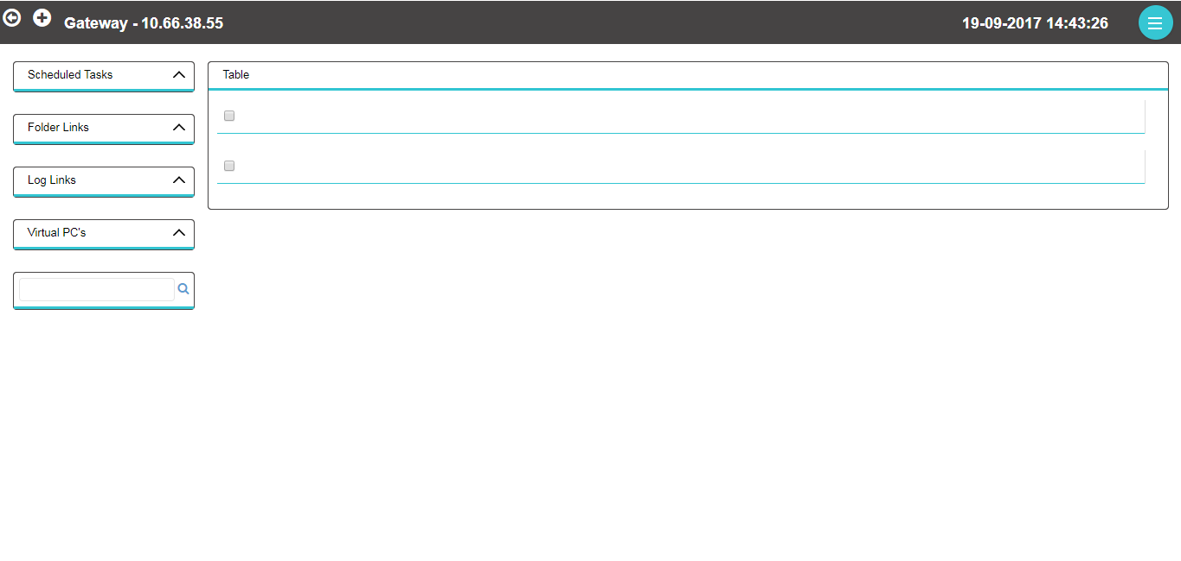

The below image shows the left part of the header of the page.

1

2

3

Untitled9.png

1. **Back** Button- To navigate to the previous page.
2. **Manual Process** Button- On click of this button a dropdown menu will appear as shown in below image.

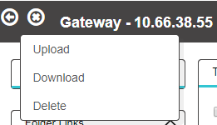

* 1. **Upload**- Uploads a file on the server to the path specified in Folder Path control.

The user can drop files or select files to upload. By clicking on “Upload” button the files will get uploaded. Clicking on “Close” button will close the popup modal dialog.

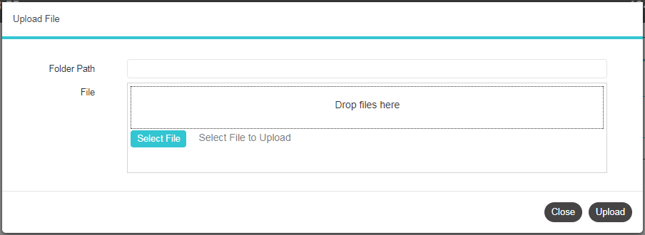

* 1. **Download**- Downloads a file from the server.

The user should specify the path with filename in File Path box and then click on “Download” button to download the file.

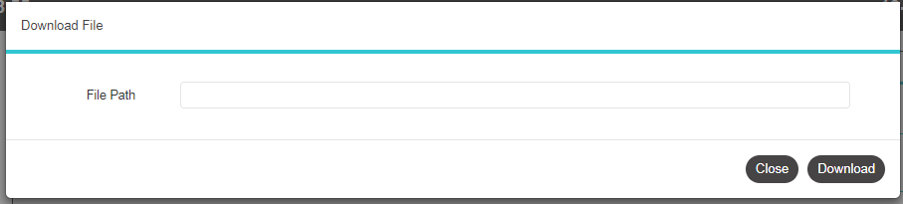

* 1. **Delete**- Deletes a file from the server.

The user should specify the path with filename in File Path box and then click on “Delete” button to delete the file.

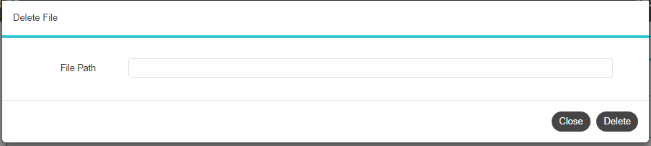

1. Show the Server name and its IP address.

The below image shows the right part of the header of the page.

Untitled14.png

It shows the time as on the server. The time is refreshed only when the “Refresh” of the Quick navigation button is executed and also after the console application which will run for every one hour.

The below image shows the left part of the body of the page.

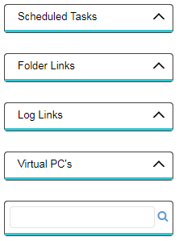

**Collapsible Menu’s**-

**Scheduled Tasks** - Denotes the tasks on the task scheduler of the server.

**­Folder Links**- Denotes the folders which are accessed frequently.

**Log Links**- Denotes the folders containing log files.

**Virtual PC’s**- Denotes the virtual PC’s present on that server.

Last Menu will provide user with a tree view of folders by specifying the root folder path in the textbox and clicking on search as shown in below image.

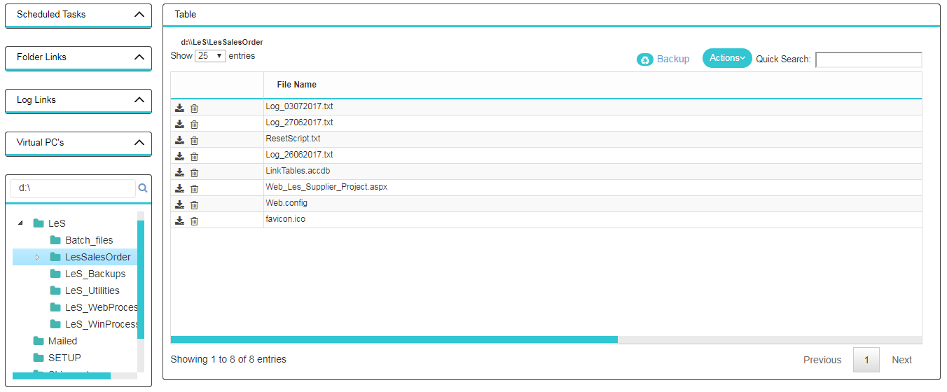

All the other controls on the grid work same as this.

**Scheduled Tasks**-



By clicking on the highlighted button in the above image the Menu will expand showing a link and again clicking on the same will collapse.

By clicking on the link the tasks details of that server will get displayed in the grid to the right of the body as shown in below image.

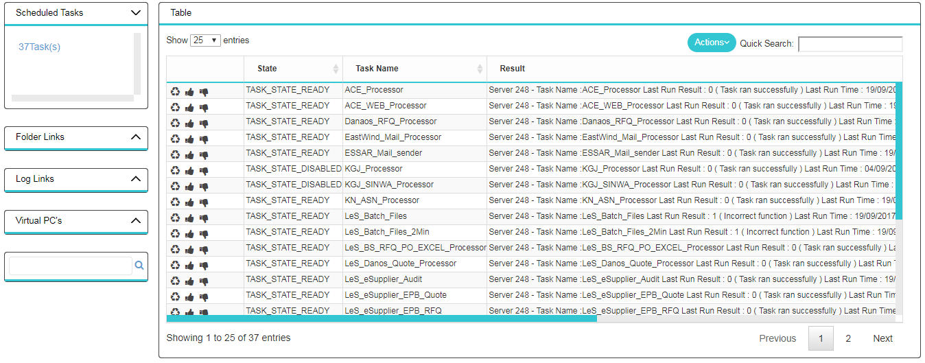

1

2

3

Untitled17.png

1. **Rerun**- On click of this button will Rerun the particular task.
2. **Enable**- On click of this button will enable the particular task.
3. **Disable**- On click of this button will disable the particular task.

Untitled18.png

On click of the above button a refresh menu will dropdown as shown in the image below. “Refresh” will refresh the task list in the grid.

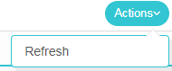

**Folder Links**-

1

2

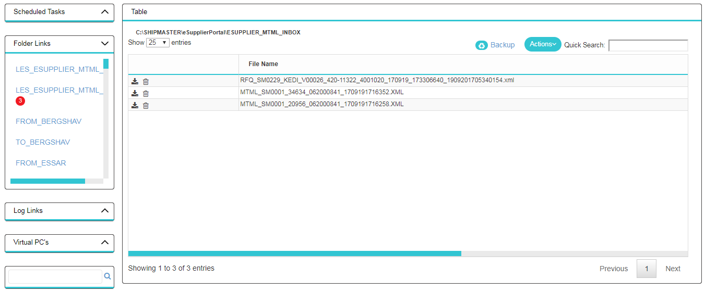

By clicking on the links in Folder links the details of the files present in that folder will be displayed in the grid to the right of the body.

1. Specifies the total number of files present in that folder.
2. Shows the full path of that folder.

3

4

5

6

Untitled21.png 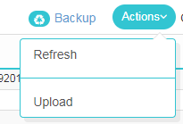

1

2

**File Controls**-

1. Download- Downloads the specific file.
2. Delete- Deletes the specific file, where a “deleted” folder is created on the path and the file is moved to that folder.
3. Gets the information of the Backup files count present in the “backup” named folder on path and displays it in a label with count shown in below image.

Untitled23.png Untitled28.png

Red color if the count is greater than 5000 else displays it in green color.

1. On clicking the backup link a popup modal dialog will open as shown below.

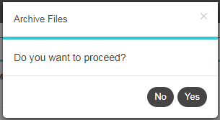

If the user clicks on “Yes” button the files will get archived, means the files will get moved to another folder path (the path is specified in the Config of the project.)

If the user clicks on “No” button the popup modal dialog will close without archiving any files.

1. On click of this menu option the file list of path will get refreshed and displayed in grid.
2. On click of this menu option a popup modal dialog as shown below will get displayed.

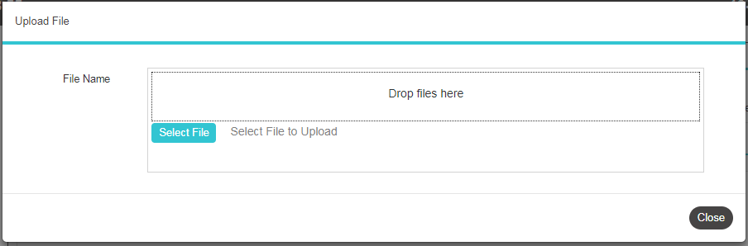

This modal popup will help the user in uploading files to path.

6) On click of the server LED or the label for task(s) count, the page shown in the below image will be displayed only if the LED is Red in color. Only the tasks of this are displayed in the grid. The functionality is same as this.

